Python DA Assignment 1: Data Analysis using NumPy and Pandas
Numpy Array Operations:
Problem Statement: To learn how to use NumPy for creating arrays, performing basic array operations, and conducting numerical computations through analyzing temperature data.
Scenario: You are given a list of daily average temperatures (in degrees Celsius) recorded over two weeks. Your task is to use NumPy to analyze this data.
Step wise Instructions:
1. Create a 1D NumPy Array:
Create a 1D NumPy array named temperatures_w1 for Week 1 with the following values:
[22.5, 25.3, 20.8, 23.4, 26.1, 24.8, 21.9]

PYTHON CODE WITH OUTPUT

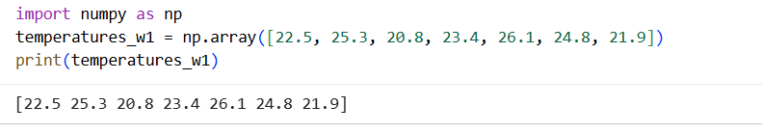

2. Inspection and Properties:
● Inspect the shape, data type, and the number of elements in the array. Inspect the shape of the temperatures_w1 array.
PYTHON CODE WITH OUTPUT
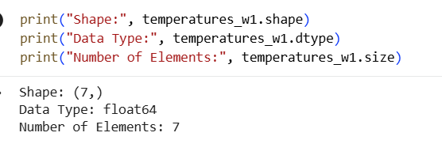
3. Array Operations:
● Convert the temperatures_w1 from Celsius to Fahrenheit using the formula: Fahrenheit = (Celsius * 9/5) + 32
● Find the maximum, minimum, and mean temperatures for the week.

PYTHON CODE WITH OUTPUT
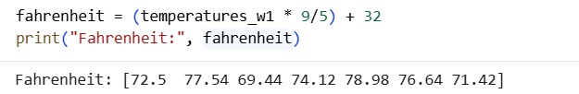

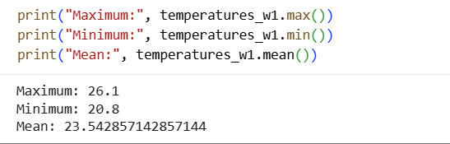

4. Array Slicing and Indexing:
● Extract the temperatures for the first three days of the week.
● Extract the temperatures for the weekend (last two days).
● Extract the temperatures for the middle three days of the week.
PYTHON CODE WITH OUTPUT
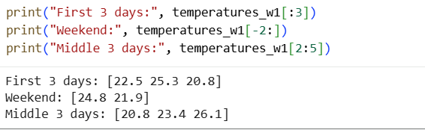
5. Create a 2D Array:
Create a 2D NumPy array named temperatures where each row represents temperatures for a different week:
★ Row 1: [22.5, 25.3, 20.8, 23.4, 26.1, 24.8, 21.9] (Week 1) ★ Row 2: [19.2, 22.5, 21.3, 24.0, 23.5, 22.8, 20.1] (Week 2)

PYTHON CODE WITH OUTPUT
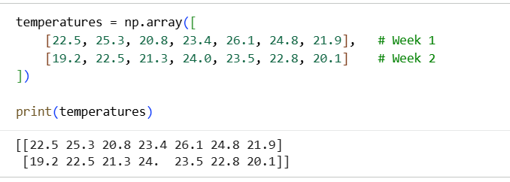

6. Inspect and Slice the 2D Array:
● Inspect and print the shape, data type, and total number of elements in the temperatures array.
● Extract the temperatures for each week and the weekends (last two days) for both weeks.

PYTHON CODE WITH OUTPUT
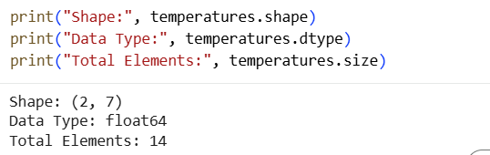
Pandas Series:
1. Creating Pandas Series:
● Create a Pandas Series named marks with the following data:
➢ Marks: 95, 92, 89, 85, 80
➢ Custom Indices: 'Rank1', 'Rank2', 'Rank3', 'Rank4', 'Rank5'

PYTHON CODE WITH OUTPUT

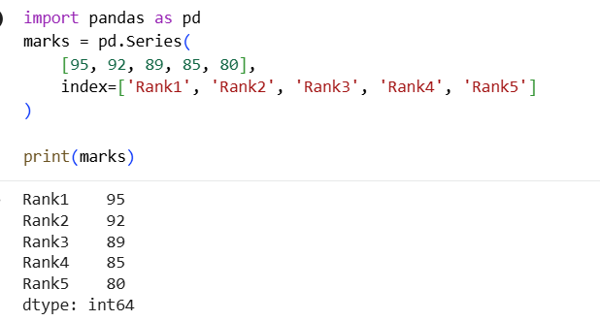

2. Indexing and Slicing:
● Use the integer index position to access the mark of the 1st rank student.
● Use the loc accessor to retrieve the marks of the top 3 ranks by specifying their index labels.
● Use the iloc accessor to retrieve the mark of the 3rd rank student.
● Apply a boolean mask to filter the Series and retrieve the ranks where the marks are greater than 90.

PYTHON CODE WITH OUTPUT
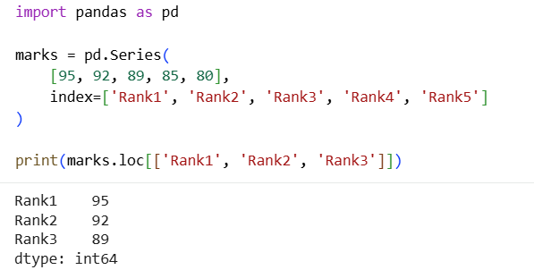
3. Manipulating Series:
● Modify the mark of the student with the 1st rank to 100.
● Remove the entry corresponding to the last rank from the Series. ● Compute the CGPA by dividing each mark in the Series by 10.

PYTHON CODE WITH OUTPUT
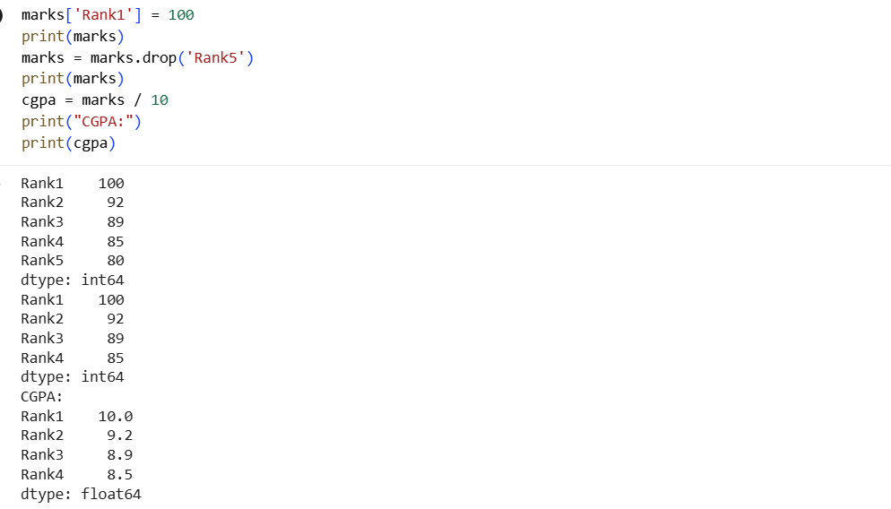

Pandas DataFrame:
1. Creating Pandas DataFrame:
● Create a Pandas DataFrame named transactions with the following data: ➢ TransactionID: 101, 102, 103, 104, 105, 106, 107, 108, 109, 110
➢ ProductCategory: 'Electronics', 'Clothing', 'Electronics', 'Furniture', 'Clothing', 'Electronics', 'Furniture', 'Clothing', 'Furniture', 'Electronics'
➢ Region: 'North', 'South', 'North', 'East', 'West', 'North', 'East', 'West', 'South', 'North'
➢ Amount: 200, 150, 300, 450, 200, 250, 300, 180, 350, 400

PYTHON CODE WITH OUTPUT
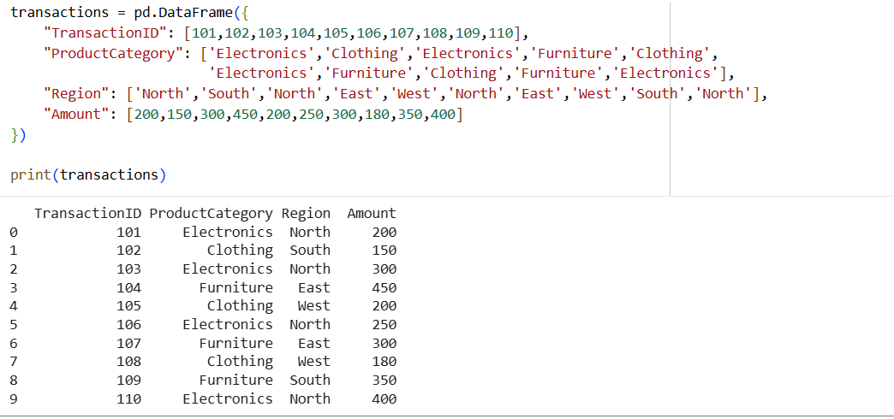
2. Data Exploration:
● Display the transactions DataFrame and its basic information, including head, tail, shape, column names, and data types.
● Display only the 'ProductCategory' and 'Amount' columns.
● Retrieve the last 3 columns of the DataFrame using iloc or loc. ● Filter rows where the 'Region' is 'North' and 'Amount' is greater than 200. ● Find the value counts for the 'ProductCategory' column.
● Find the unique values in the 'Region' column.
● Group by 'Region' and find the mean amount for each region.

PYTHON CODE WITH OUTPUT
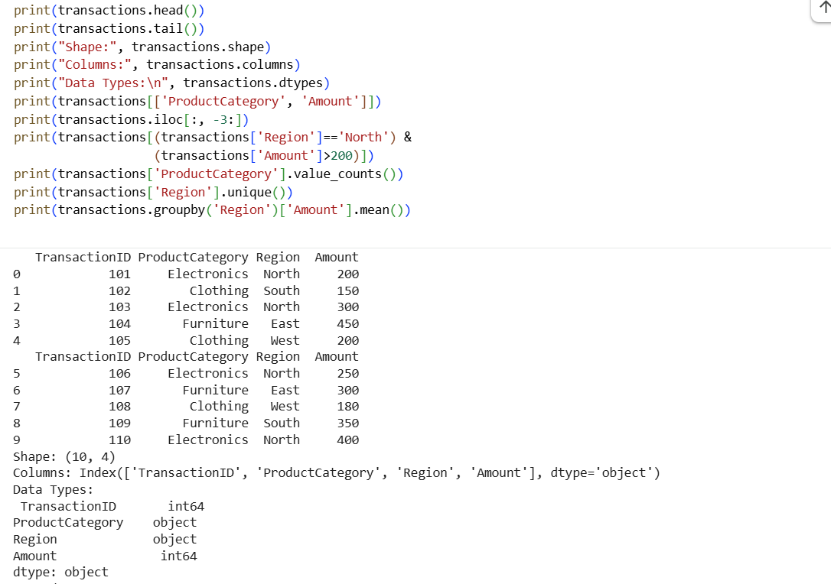

3. Manipulating the DataFrame:
● Modify the 'Amount' for the transaction with TransactionID 102 to 165. ● Add a new column 'Discount' by calculating 10% of the 'Amount'. ● Remove the row with TransactionID 109.
● Delete the 'Discount' column from the DataFrame.

PYTHON CODE WITH OUTPUT

